**Negative Impact of Internet In The Modern World**

**Preliminary outline:**

I. Introduction

General statements:

Controversial issue: Benefits of using the internet in the modern world.

Opposing camps: Drawbacks of the internet.

Thesis statement: The major uses of the Internet that play a vital role in daily life. Education, online banking& trading, social networking, cashless transaction, entertainment, online booking and orders, navigation, file transfer, E-commerce, entertainment, Navigation, real-time updates, job search.

II. Body

A. Opposing Argument 1

The email has enabled faster communication between people on the Internet.

Rebuttal to Argument 1

1. Email lacks a personal touch.
2. Email cannot be ignored for a long time.
3. Email can cause misunderstandings.
4. Email messages can contain viruses.

B . Opposing Argument 2

people can quickly share information, data files, such as images, audio, video, and

other types of files through internet so quickly.

Rebuttal to Argument 2

1. There is an increased risk of malware, ransomware, and viruses of infecting shared files.
2. When files are shared, there is a higher risk external hacker could attempt to share company data in a public forum online.

C. Opposing Argument 3

Internet is used in cashless transaction. People can pay their bills through debit or credit cards. This helps people not carry much cash.

Rebuttal to Argument 3

1. But it is concered of hacking. Fraudsters, for instance, use phishing attacks to trick unsuspecting users into providing the log-in details of their e-wallets.
2. Hackers capture and use to access the victims' personal and financial information.

III. Conclusion

1. **Draft 1**

**Importance Of Internet Technology For Easy Life**

For all its advantages and positive aspects, the internet has its dark and ugly side too. Now a days some students will spend too much of time through the internet. Students are likely to neglect their studies. If the movie has too strong a hold even elderly people are likely to neglect some their important work. Students might lose concentrate on their studies because they spent too much time on internet. Some of them can even divide their time to do homework but they spent their time on watching movie or chatting with their friends through internet.

While the internet has made life easier for people in many ways it is also reflecting an uglier side to its existence through a number of problems that it has thrown up for its users. With a large amount of information freely available on the internet theft and misuse of this information is a likely possibility. Time and again you see cases of people using someone else’s information and research and passing it off as their own. Children nowadays seem losing their ability to communicate with others. They are used to communicate with others via internet but they cannot communicate with others face by face fluent. It was a strange sight that internet had make people losing their ability to communicate. It is because people now are over depending on internet.

Another problem or disadvantage of the internet is that it has allowed a great deal of anonymity to a large number of people who may access the different websites, forums and chat rooms available. This has allowed perverted individuals to at times take advantage of innocent people and abuse their trust. We can always hear from news that cheaters used internet to make crimes. The cheaters will make friends with single ladies and cheat them by using sweet words. Lonely single ladies are very easy get in trap of these cheaters. These cheaters normally will cheat these ladies to bank-in money to them. Some of the cheaters try to borrow money from these ladies.

There are a host of games that are available on the internet and this has made most children to shun all outdoor activity. In the absence of physical activity, children can easily fall prey to a lot of lifestyle related diseases such as obesity, apart from failing to develop interpersonal skills. Apart from these factors, sitting continuously in front of a computer screen can seriously damage our eyes, and put a strain on our neck and shoulders. Children are in their developing years and these factors can create life-long problems for them. Children will become more violence because affected by internet games. There are too many internet games that contain violence content and it may affect negative influence to children.

Another disadvantage of internet is harmful to little children. Children nowadays are explored to internet and they are used to maintain internet as their daily life. This is one of the greatest threats internet poses to children. Internet has provided an easy medium to children to gain access to pornography and this can cause them to either become sexually-deviant or sexually-addictive. This phenomenon has also caused another problem, and that is the increase in prevalence of sexually transmitted diseases (STD) in children. According to reports, one out of every four teenagers gets infected with a STD every year. The adult content that is present on the internet promotes irresponsible sex and creates false notions in the minds of students.

Children have been lured by paedophiles posing as good Samaritans and have been physically abused and molested. Internet has also made it easy for unscrupulous elements to get in touch with children and this has led to an increase in the cases of kidnapping and identity thefts. About 60% young teens in the United States have admitted to responding to messages from strangers. This kind of behaviour is extremely risky and has made children extremely vulnerable to become victims of cyber-crime.

（ words）

1. **Draft 1（with self-review）**

**Importance Of Internet Technology For Easy Life**

Internet is a global communication system that links together thousands of individual networks. It allows the exchange of information between two or more computers on a network.

The Internet plays a very vital role in education. It is no doubt that in this modern era everyone prefers Google for their queries, problems, or doubts. Popular **search engines** like Google, Yahoo, etc. are the topmost choice of people as they offer an easy and instant reach to the vast amount of information in just a few seconds. It contains a wealth of knowledge that can be searched **at any time**. The internet has introduced improvements in technology, communication, and online entertainment. Besides, the Internet has also enabled students to participate in their classes through **video conferencing**, where students can **connec**t with their teachers or professionals anywhere in the world.

Email or electronic mail is one of the **first significant** uses of the Internet. Email has enabled **faster** **communication** between people on the Internet. Using email, people can quickly **share information, data files,** such as **images**, **audio**, **video**, and other types of **files**. The use of email has significantly **reduced** **paper use**, which was the primary source of communication in the olden days. Anyone can have a **free email address** and can easily **communicate** with others. This has also reduced the load on the physical mail system, although it is still in use

Due to the Internet, **communication** has become easier and better. You can easily **connect** with anyone on the Internet, either **textin**g, **calling,** or **video calling**. It has created new **cooperation opportunities** for the people. There are **several online chat** **software** and **website**s that help people create group discussions or meetings. It helps businesses to have a hassle-free discussion. Therefore, people do not always need to travel long distances to attend meetings. This helps people avoid **unnecessary travel** and **save time** for productive use. Besides, there are many cloud-based software and websites that offer people to work on the same project simultaneously at the same time. People from different places can easily connect and support their specialties using the Internet

The Internet is the most effective means of **entertainmen**t. There are various options available on the Internet, which people can try, such as **watching movies**, **playing online games**, **listening to songs**, etc. The Internet has also made it easy for people to **download** entertainment items to their **local storage**. Using the Internet, people can also share their videos, songs, pictures online with others. Also, nowadays, people can watch **live TV** or **sports** on the Internet.

Most countries are promoting **cashless transactions** and **digital payments**. This helps people **not carry much cash**. People can pay their bills through **debit or credit cards** using POS devices. These devices are connected to the payment gateway on the Internet. Besides, People can also use their smartphones and the Internet for processing transactions on UPI (Unified Payment Interface). It does not even require them to carry their cards. The UPI payment method is continuously evolving and is expected to cover most transactions in the near future.

In the conclusion, today we cannot even think of a single moment without the internet. This epidemic **COVID-19** we are more dependent on the internet like an **online class**, **online shopping**, **online food delivery**, online ticket booking, etc. So, day by day the internet is helping our life easier. The government has also provided free internet facilities in public places. The Internet is the most popular technology used today. Millions today, use the internet through devices like phones and computers. We cannot work properly without the internet. We also must be careful while using the internet. We must not get addicted to it. It should be used only when it is necessary.

**Self -Review**

1. The essay is to inform.
2. The essay belongs to the logical-division-of-ideas type.
3. It is a funnel introduction, indicating the explicit limitation of the topic.
4. It has a thesis statement (TS) which specifies the thesis of the whole essay, including the specific topic and the subtopics.
5. It has at least 600 words.
6. The essay has a fairly formal style:
7. Its language is specific and accurate, not general and vague :
8. Repeating key words.
9. Arranging the ideas in a logical order or explicit patterns of organization.
10. It is characterized by the frequent use of formal.
11. **Final Outline**

**Importance Of Internet Technology For Easy Life**

1. **Introduction**

**General statement:** The Internet is a global communication system that links together thousands of individual networks. It allows the exchange of information between two or more computers on a network.

**Thesis statement：** The major uses of the Internet that play a vital role in daily life. Education, online banking& trading, social networking, cashless transaction, entertainment, online booking and orders, navigation, file transfer, E-commerce, entertainment, Navigation, real-time updates, job search.

1. **Body**
2. **Topic sentence:** The Internet plays a very vital role in education.
3. The Internet has the availability of broad educational content on any topic with different types.
4. Internet helps eliminate the need to go to the library to read several books to find the desired information.
5. **Topic sentence:** Email or electronic mail is one of the first significant uses of the Internet
6. Email has enabled faster communication between people on the Internet.
7. Using email, people can quickly share information, data files, such as images, audio, video, and other types of files.
8. **Topic sentence:** Communication has become easier and better because of the internet.
9. With the help of the internet, we can easily connect with anyone on the Internet, either texting, calling, or video calling.
10. It helps businesses to have a hassle-free discussion.
11. **Topic sentence：** There are various options available on the internet for entertainment.
12. There are various options available on the Internet, which people can try, such as watching movies, playing online games, listening to songs, etc.

2. people can watch live TV or sports on the Internet

1. **Topic sentence:** Now the internet is used for cashless transactions and digital payment.
2. This helps people not carry much cash.
3. People can pay their bills through debit or credit cards.
4. **Conclusion**

In the conclusion, today we can’t even think of a single moment without the internet. This epidemic COVID-19 we are almost more depending on the internet like an online class, online shopping, online food delivery, etc. so, day by day internet is helping our life easier. The government has also provided free internet facilities in public places. The Internet is the most popular technology used today. Millions today, use the internet through devices like phones and computers. We cannot work properly without the internet. We also must be careful while using the internet. We must not get addicted to it. It should be used only when it is necessary.

1. **Draft 2+ References**

**Importance Of Internet Technology For Easy Life**

Internet is a global communication system that links together thousands of individual networks. It allows the exchange of information between two or more computers on a network.

The Internet plays a very vital role in education. It is no doubt that in this modern era everyone prefers Google for their queries, problems, or doubts. Popular search engines like Google, Yahoo, etc. are the topmost choice of people as they offer an easy and instant reach to the vast amount of information in just a few seconds. It contains a wealth of knowledge that can be searched at any time. The internet has introduced improvements in technology, communication, and online entertainment. Besides, the Internet has also enabled students to participate in their classes through video conferencing, where students can connect with their teachers or professionals anywhere in the world.

Email or electronic mail is one of the first significant uses of the Internet. Email has enabled faster communication between people on the Internet. Using email, people can quickly share information, data files, such as images, audio, video, and other types of files. The use of email has significantly reduced paper use, which was the primary source of communication in the olden days. Anyone can have a free email address and can easily communicate with others. This has also reduced the load on the physical mail system, although it is still in use

Due to the Internet, communication has become easier and better. You can easily connect with anyone on the Internet, either texting, calling, or video calling. It has created new cooperation opportunities for the people. There are several online chat software and websites that help people create group discussions or meetings. It helps businesses to have a hassle-free discussion. Therefore, people do not always need to travel long distances to attend meetings. This helps people avoid unnecessary travel and save time for productive use. Besides, there are many cloud-based software and websites that offer people to work on the same project simultaneously at the same time. People from different places can easily connect and support their specialties using the Internet

The Internet is the most effective means of entertainment. There are various options available on the Internet, which people can try, such as watching movies, playing online games, listening to songs, etc. The Internet has also made it easy for people to download entertainment items to their local storage. Using the Internet, people can also share their videos, songs, pictures online with others. Also, nowadays, people can watch live TV or sports on the Internet.

Most countries are promoting cashless transactions and digital payments. This helps people not carry much cash. People can pay their bills through debit or credit cards using POS devices. These devices are connected to the payment gateway on the Internet. Besides, People can also use their smartphones and the Internet for processing transactions on UPI (Unified Payment Interface). It does not even require them to carry their cards. The UPI payment method is continuously evolving and is expected to cover most transactions in the near future.

In the conclusion, today we can’t even think of a single moment without the internet. This epidemic COVID-19 we are almost more depending on the internet like an online class, online shopping, online food delivery, etc. so, day by day internet is helping our life easier. The government has also provided free internet facilities in public places. The Internet is the most popular technology used today. Millions today, use the internet through devices like phones and computers. We cannot work properly without the internet. We also must be careful while using the internet. We must not get addicted to it. It should be used only when it is necessary.

（620 word）

**Reference**

*Corbett, Philip B. (1 June 2016). "It's Official: The 'Internet' Is Over". The New York Times. ISSN 0362-4331*. (n.d.).

Luckett, H. P. (n.d.). *Luckett, Herbert P. (March 1973)*.

*Pews Research Center. 11 March 2014*. (n.d.).

1. **Attachment**

**Reference1**

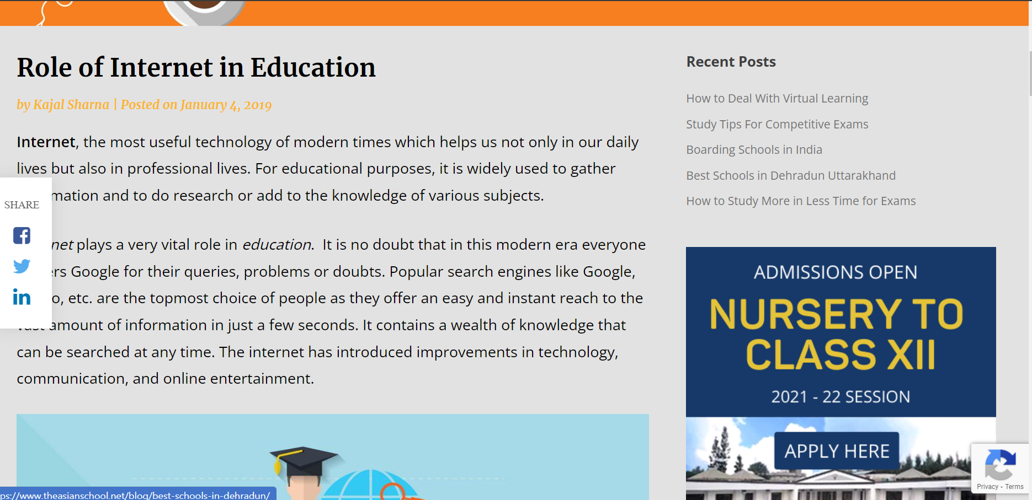

Reference 2

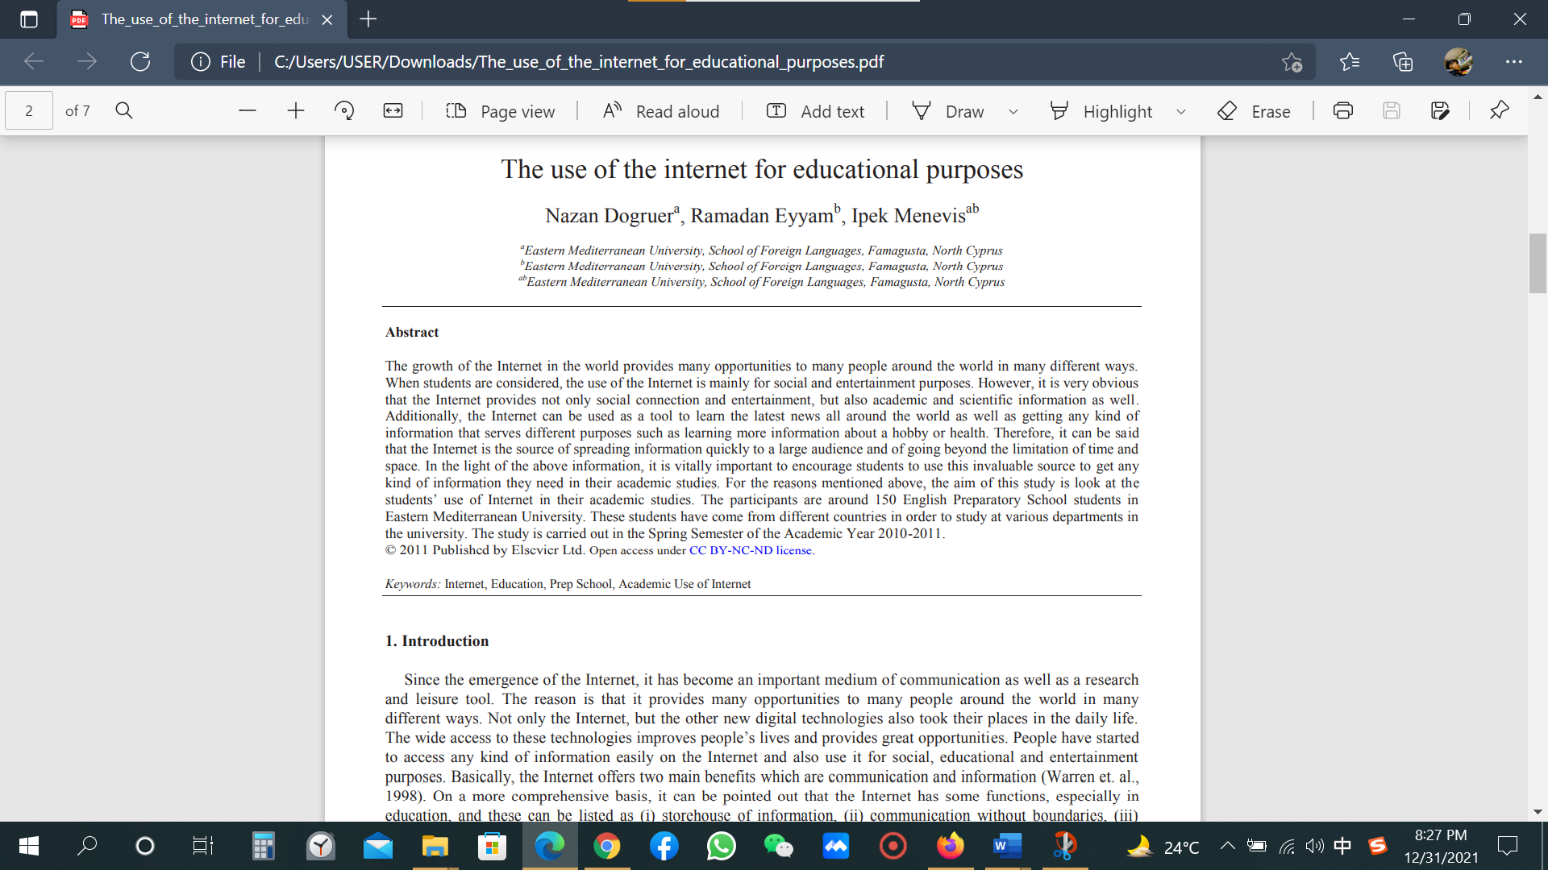

Reference3

